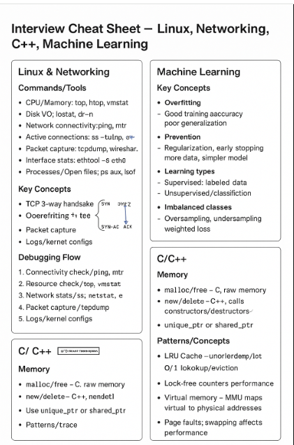

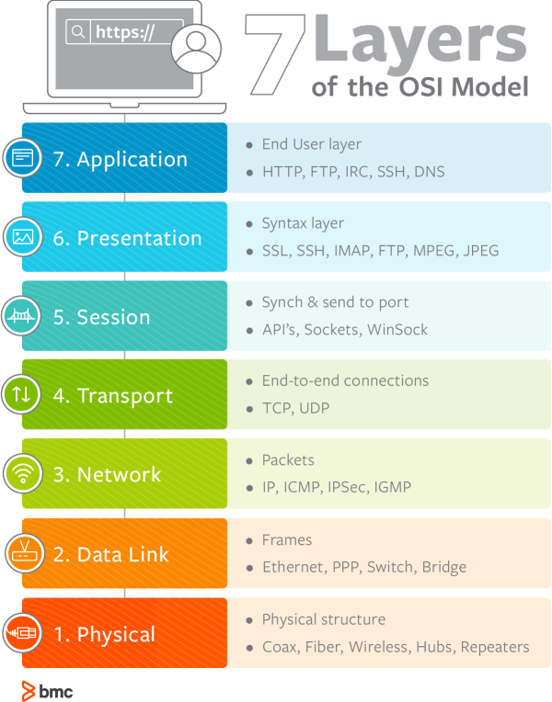

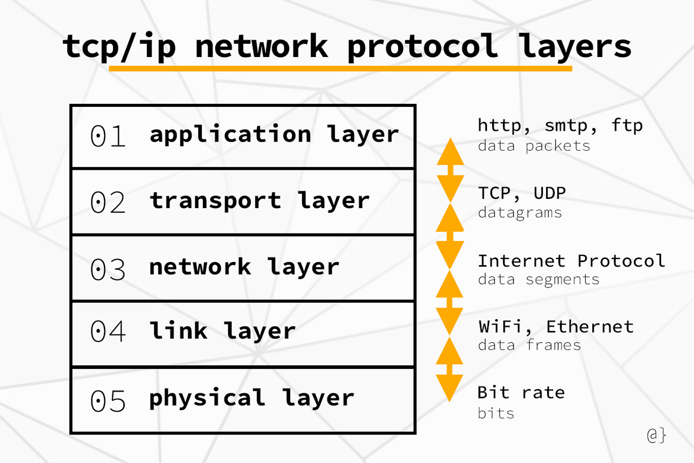

SMTP stands for Simple Mail Transfer Protocol, which is the standard internet protocol for sending email messages between mail servers. It uses a client-server model, with the Mail User Agent (email client) sending an email to a Mail Transfer Agent (MTA), which then acts as a mail relay to deliver the message to the recipient's server. While the original SMTP was limited to text, its ESMTP extension supports rich media and authentication, with modern systems often using encrypted ports like 465 or 587 for secure transmission.

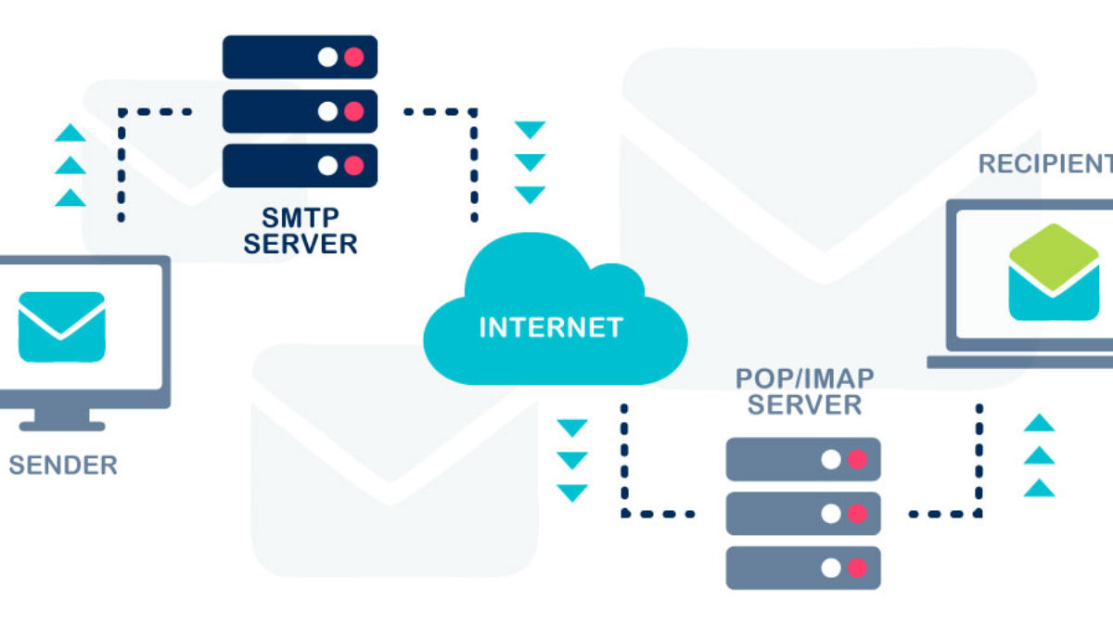
Interviewer:
Tell me about a time you disagreed with a teammate on a technical decision. How did you handle it, and what was the outcome?

👉 You can answer each question one by one, and I’ll give you feedback after each before moving to the next.
Would you like to start with Round 1 (Linux & Networking) now?

You said:
First I will login to the linux server to check the network stats, ping and MTR values

ChatGPT said:
👍 Good start — logging into the server and checking connectivity basics is the right first step.
Here’s how you could expand your answer in an interview to show a structured debugging flow:
- Step 1: Connectivity & Reachability
  - ping or mtr to check packet loss/latency.
  - Verify DNS resolution if users are reporting slow connections.
- Step 2: Resource Utilization
  - top, htop, or vmstat to see CPU, memory, and load average.
  - iostat if disk I/O could be a bottleneck.
- Step 3: Network Stack Health
  - ss -tulnp or netstat -s to see socket states.
  - ethtool -S eth0 to check for dropped packets, errors, retransmissions.
- Step 4: Deep Packet Inspection
  - tcpdump or wireshark capture to see retransmits or handshake delays.
- Step 5: Kernel & Service Configs
  - Review sysctl tuning (net.ipv4.tcp_* settings, buffer sizes).
  - Check service/application logs for slow queries or blocking threads.
If you present it this way, the interviewer sees you’re methodical, know the right tools, and can escalate from simple to complex checks.
Can you explain what overfitting is in machine learning, and give me two strategies to prevent it?
How you could answer in the interview:
Overfitting happens when a model performs very well on training data but fails to generalize to unseen data, because it has essentially memorized patterns, including noise. Two ways to prevent it are:
- Regularization (like L1 or L2 penalties, or dropout in neural nets) to limit model complexity.
- Cross-validation and early stopping to ensure the model isn’t trained too long and starts fitting noise.
You could also add: increasing training data, or using simpler models.

👉 Want to try answering Round 3 (C/C++ multithreading) yourself, and I’ll give you feedback?

You said:
Y

ChatGPT said:
Alright, here’s Round 3 (C/C++ and Systems):
Interviewer:
Imagine you’re implementing a multithreaded program in C++. What problems could arise if two threads try to update the same shared variable at the same time, and how would you solve them?
👉 Give it a try, and I’ll help refine your answer.

You said:
When two threads try to update the same shared variable at the same time, a deadlock situation may occur as one thread locks the resources needed by another threads.

ChatGPT said:
That’s a good effort — you’re thinking about concurrency problems — but let’s fine-tune it.
What actually happens when two threads update the same variable at the same time is usually a race condition, not a deadlock.
- Race condition: Both threads read and write without synchronization, so the result depends on timing. For example, if both increment a counter, you might lose updates.
- Deadlock: Happens when two or more threads hold different locks and wait forever on each other. That’s a slightly different situation.
How you could answer in an interview:
If two threads update the same shared variable without synchronization, you get a race condition where the final value may be incorrect or inconsistent. To fix this, you can use:
- Mutexes/locks to ensure only one thread updates the variable at a time.
- Atomic operations (std::atomic in C++) for lightweight synchronization on counters or flags.
- Or design for lock-free concurrency when performance is critical.

Interviewer:
Tell me about a time you disagreed with a teammate on a technical decision. How did you handle it, and what was the outcome?
Go ahead and answer as if you’re in the interview, and I’ll give you feedback and suggestions to make it stronger.

You said:
When I was in Intel as a techincal lead I had noticed some coding practices which caused system to keep the legacy code for ever and build new features on top and this caused several customer tickets in production. I proposed a cleaner solution to my manager who didn't agree and or nor is acknowledging the issues are because of this. I had to take few cycles from my work to implement a solution which separates legacy implementation from new implemention with fewer lines.onvinced

ChatGPT said:
That’s a solid example — it shows initiative and problem-solving — but it needs polishing for clarity and flow, so the interviewer can easily follow the situation, your action, and the result.
Here’s a refined version using the STAR method:

Answer (refined):
Situation: At Intel, as a technical lead, I noticed that our codebase was retaining legacy implementations while building new features on top. This caused several customer issues in production.
Task: I needed to propose a cleaner solution that would reduce technical debt and prevent these recurring issues.
Action: I presented my proposal to my manager, but initially, they didn’t agree or acknowledge that the legacy code was the root cause. I decided to take a few cycles from my own work to implement a solution that separated the legacy code from the new implementation, keeping it cleaner and more maintainable.
Result: This approach reduced code complexity, made future features easier to implement, and decreased production issues related to legacy interactions. It also demonstrated proactive problem-solving and ownership.

Tips for delivery:
- Keep it concise: 1–2 minutes.
- Emphasize your initiative and impact, not the disagreement.
- Avoid negative phrasing (“manager didn’t agree”); focus on what you did.

If you want, I can create a complete practice script combining all four rounds, including follow-ups, so you can rehearse a full interview scenario from start to finish. This would include Linux, Networking, ML, C/C++, and Behavioral in one session. Do you want me to do that?
Perfect. Here’s a full mock interview script you can use to rehearse. It’s structured as a four-round session with technical and behavioral questions, plus suggested follow-ups and tips for answers. You can practice responding aloud as if it’s a real interview.

🔹 Full Mock Interview Script

Round 1: Linux & Networking
Q1: You’re on call, and users report that a web service is suddenly slow. Walk me through how you would debug this on a Linux server.
- Follow-ups:
  - What Linux tools would you use to check CPU, memory, or disk usage?
  - How would you isolate a network bottleneck?
  - How would you debug packet loss or retransmissions?
- Answer tips: Start with basic connectivity (ping, mtr), then resource usage (top, vmstat), network stack (ss, netstat), packet capture (tcpdump), and finally kernel/config checks. Explain step-by-step logic.
Q2: Explain the TCP 3-way handshake. What happens if the last ACK is lost?
- Answer tips: SYN → SYN-ACK → ACK; if last ACK is lost, server may keep a half-open connection until timeout.

Round 2: Machine Learning
Q1: What is overfitting, and how do you prevent it?
- Follow-ups:
  - How do you handle a dataset that’s too large to fit in memory?
  - How do you deal with imbalanced classes?
- Answer tips:
  - Overfitting = model performs well on training data but poorly on unseen data.
  - Prevention: regularization (L1/L2/dropout), cross-validation, early stopping, more data.
  - For large datasets: minibatching, distributed training.
Q2: Explain the difference between supervised, unsupervised, and reinforcement learning.
- Answer tips:
  - Supervised: labeled data, predict output.
  - Unsupervised: find patterns/clusters without labels.
  - Reinforcement: agent learns via rewards/penalties.

Round 3: C/C++ and Systems
Q1: Imagine two threads update the same variable at the same time. What could go wrong, and how do you solve it?
- Follow-ups:
  - How do mutexes work?
  - When would you use atomic operations instead of locks?
- Answer tips: Race condition is the key issue. Solve with std::mutex or std::atomic. Deadlocks are related but different.
Q2: What’s the difference between malloc/free and new/delete in C++?
- Answer tips: malloc/free = raw memory, no constructor/destructor. new/delete = C++ style, calls constructor/destructor automatically. Mention smart pointers.
Q3: Implement an LRU cache (high-level description).
- Answer tips: Use unordered_map for key → iterator, list for LRU ordering. O(1) lookup and eviction.
Q4: What is virtual memory in Linux, and how does it affect performance?
- Answer tips: Each process has its own virtual address space. MMU translates virtual → physical addresses. Page faults, swapping, and hugepages affect performance.

Round 4: Behavioral / Communication
Q1: Tell me about a time you disagreed with a teammate on a technical decision.
- Answer tips: Use STAR method. Focus on your action and result, not conflict. Keep it concise (1–2 minutes).
Q2: How do you explain a complex technical issue to a non-technical stakeholder?
- Answer tips: Use analogies, avoid jargon, focus on impact and solution.
Q3: What is your involvement in technical communities?
- Answer tips: Mention open-source contributions, mentoring, talks, forum participation. Shows leadership beyond coding.

Practice Flow
- Start Round 1 questions; answer aloud as fully as possible.
- Receive feedback (or self-review: did you explain tools, reasoning, next steps?).
- Move to Round 2, then 3, then 4.
- For each question, try to add a real example or experience where possible.

If you want, I can also create a cheat sheet with key commands, C++ patterns, ML concepts, and Linux/network troubleshooting steps, so you have a quick reference to study right before the interview. This can help reinforce answers under time pressure.
Do you want me to make that cheat sheet?
Perfect. Here’s a concise interview cheat sheet covering Linux, Networking, C/C++, and Machine Learning. It’s designed for quick review before your interview.

🔹 Interview Cheat Sheet

1. Linux & Networking
Basic Tools & Commands
Task | Command/Tool
Check CPU/Memory | top, htop, vmstat
Disk I/O | iostat, df -h
Network connectivity | ping, mtr
Active connections | ss -tulnp, netstat -s
Packet capture | tcpdump, wireshark
Interface stats | ethtool -S eth0
Process info | ps aux, lsof
Key Concepts
- TCP 3-way handshake: SYN → SYN-ACK → ACK
- TCP vs UDP: TCP = reliable, connection-oriented; UDP = faster, connectionless
- Common issues: packet loss, retransmission, latency, half-open connections
Debugging Approach
- Check connectivity (ping, mtr).
- Check system resources (top, vmstat).
- Check network stats (ss, netstat, ethtool).
- Capture traffic if needed (tcpdump).
- Check application logs, kernel configs, sysctl settings.

2. Machine Learning
Core Concepts
- Overfitting: Model performs well on training, poorly on unseen data
- Prevention:
  - Regularization (L1/L2, dropout)
  - Cross-validation, early stopping
  - Increase training data, simpler model
- Learning Types:
  - Supervised: labeled data, classification/regression
  - Unsupervised: clustering, PCA
  - Reinforcement: agent learns via reward signals
Large Datasets
- Minibatch/streaming, sharding, distributed training (Horovod, parameter servers)
Imbalanced Classes
- Oversampling, undersampling, weighted loss

3. C/C++ and Systems
Memory Management
- malloc/free → C-style, raw memory
- new/delete → C++ style, calls constructor/destructor
- Use unique_ptr / shared_ptr for safety
Multithreading / Concurrency
- Race condition: Multiple threads update shared variable unsafely
- Solution: std::mutex or std::atomic
- Deadlock: Avoid circular waits; acquire locks in consistent order
Common Patterns
- LRU Cache: unordered_map + list for O(1) lookup/eviction
- Lock-free or atomic counters for performance-critical sections
Linux Systems
- Virtual memory: MMU maps virtual → physical addresses
- Page faults, swapping, hugepages affect performance
- Profiling: perf, strace

4. Behavioral / Communication
STAR Method for answers:
- Situation: Context of the problem
- Task: Your responsibility
- Action: Steps you took
- Result: Outcome / impact
Tips:
- Emphasize your initiative and impact
- Keep answers 1–2 minutes
- Use examples from past work, contributions, or community engagement
Common Questions:
- Disagreement with teammate → show collaboration and resolution
- Explaining technical issue to non-technical → use analogies, focus on impact
- Community involvement → open-source, mentoring, talks

This cheat sheet is compact enough to review quickly but covers the main points you’ll likely be asked.
If you want, I can also make a one-page “commands & concepts quick reference” with just key Linux commands, C++ patterns, networking terms, and ML rules, perfect to glance at right before the interview.
Do you want me to make that one-page version?
Here’s a one-page quick reference you can review right before your interview. It’s concise, focused on commands, patterns, and concepts.

🔹 Interview Quick Reference – Linux, Networking, C++, ML

1. Linux & Networking
Commands / Tools
- CPU / Memory: top, htop, vmstat
- Disk I/O: iostat, df -h
- Network connectivity: ping, mtr
- Active connections: ss -tulnp, netstat -s
- Packet capture: tcpdump, wireshark
- Interface stats: ethtool -S eth0
- Processes / Open files: ps aux, lsof
Key Concepts
- TCP 3-way handshake: SYN → SYN-ACK → ACK
- TCP = reliable, connection-oriented; UDP = fast, connectionless
- Common network issues: packet loss, retransmission, latency, half-open connections
Debugging Flow
- Connectivity check (ping, mtr)
- Resource check (top, vmstat)
- Network stats (ss, netstat, ethtool)
- Packet capture (tcpdump)
- Logs / kernel configs

2. Machine Learning
- Overfitting: Good training accuracy, poor generalization
  - Prevention: Regularization, early stopping, more data, simpler model
- Learning types:
  - Supervised → labeled data, regression/classification
  - Unsupervised → clustering, PCA
  - Reinforcement → agent learns via reward
- Large datasets: Minibatch, sharding, distributed training
- Imbalanced classes: Oversample/undersample, weighted loss

3. C/C++ & Systems
Memory
- malloc/free → C, raw memory
- new/delete → C++, calls constructors/destructors
- Use unique_ptr / shared_ptr for safety
Concurrency
- Race condition: simultaneous update → inconsistent results
  - Fix: std::mutex, std::atomic
- Deadlock: circular waits → avoid nested locks
Patterns / Concepts
- LRU Cache: unordered_map + list → O(1) lookup/eviction
- Lock-free counters for performance
- Virtual memory: MMU maps virtual → physical addresses; page faults, swapping affect perf
- Profiling: perf, strace

4. Behavioral / Communication
STAR Method
- Situation: Context
- Task: Your responsibility
- Action: Steps taken
- Result: Outcome
Tips
- Focus on impact and initiative
- Keep answers 1–2 minutes
- Use examples from work, projects, or community involvement
Common Questions
- Disagreement with teammate → collaboration & resolution
- Explaining technical issues to non-technical → analogies & impact
- Community contributions → open-source, mentoring, talks

This is short enough to review in 5–10 minutes before your interview and gives you the essentials at a glance.
If you want, I can also make a visual “cheat sheet diagram” that organizes Linux, Networking, C++, and ML into boxes for even faster recall. This works well for mental mapping under pressure.
Do you want me to make that visual version?

🔹 Full Mock Interview Simulation

Round 1: Linux & Networking
Q1:
You’re on call, and users report that a web service has suddenly slowed down. Walk me through how you’d investigate the problem on a Linux server.
👉 Please answer this first question, and then I’ll give you feedback before moving to the next.

You said:
First I will login to the linux machine and run ping or mtr commands for network configurations

ChatGPT said:
👍 Good start — checking basic connectivity is the right entry point.
To make this answer interview-ready, add more structure so it shows a methodical escalation instead of just one or two commands. Here’s how you could extend it:
Answer (refined):
First, I’d log into the server and check basic connectivity using ping or mtr to see if there’s packet loss or high latency.
Next, I’d look at system resource usage with tools like top, htop, or vmstat to see if CPU, memory, or I/O are bottlenecks.
If the host looks healthy, I’d move to the network stack using ss -tulnp or netstat -s to check socket states, and ethtool -S eth0 for interface errors.
If needed, I’d capture packets with tcpdump to identify retransmissions or slow handshakes.
Finally, I’d check application logs and kernel tuning parameters (sysctl net.ipv4.tcp_*) to rule out misconfigurations.
This way, you’re showing the interviewer you start simple, then drill down step by step, and that you know multiple Linux tools for debugging.

✅ Good — that’s Round 1, Q1.
Do you want to try Round 2 (Machine Learning) now, or do you want me to give you another Linux/Networking follow-up before moving on?
Top of Form

Q2 (ML):
Can you explain what overfitting is in machine learning, and give me two concrete strategies to prevent it?
👉 Please answer as if you’re in the interview.

You said:
In ML overliftting is basically only knowing the trained models well and not knowing the known data

ChatGPT said:
You’re on the right track — you’ve captured that overfitting is about a model doing well on training data but failing to generalize. Let’s polish it into a strong interview answer:
Answer (refined):
Overfitting in machine learning happens when a model learns the training data too closely, including noise and outliers. It performs very well on the training set but fails to generalize to unseen data.
Two common ways to prevent it are:
- Regularization techniques such as L1/L2 penalties or dropout, which reduce model complexity.
- Cross-validation and early stopping, so training halts before the model starts fitting noise.
You can also mention adding more training data or simplifying the model if you want to give a broader view.
Alright — let’s move to Round 3 (C/C++ and Systems).
Q3 (C++/Systems):
Imagine you’re writing a multithreaded C++ program, and two threads try to update the same shared variable at the same time.
- What problem can occur in this situation?
- How would you solve it?
👉 Please answer as if you’re in the interview.

You said:
when two threads try to update the same shared variable at the same time race condition occurs. This race condition can be avoided by either using a mutex lock on the variable and or using a shared counter so that when one thread tries to update the variable it locks the variable before update and the other on will wait on the lock to be released before making changes to the variable.

ChatGPT said:
✅ Excellent — that’s a strong answer. You correctly identified race conditions as the main issue and gave the right fix (synchronization). A couple of small tweaks will make it even sharper in an interview:
Polished version:
When two threads update the same shared variable at the same time, a race condition occurs because the updates are not atomic, and the final result can be inconsistent.
To fix this, I can use synchronization primitives like a std::mutex so only one thread updates the variable at a time. Alternatively, for simple counters or flags, I’d use std::atomic, which is lighter and avoids explicit locks.
That shows you understand both mutex-based and lock-free approaches.
That’s a great example — you’re showing initiative, problem-solving, and persistence. It just needs some restructuring so it’s clear and concise. In behavioral questions, interviewers love the STAR method (Situation, Task, Action, Result). Here’s a polished version:

Answer (refined STAR format):
Situation: When I first joined Intel as a software engineer, I was working on system software tools for Xeon Phi coprocessors. I noticed that the codebase contained a lot of legacy device support, which made the stack complex and was causing many customer defects.
Task: I felt we needed a cleaner approach that separated legacy support from new device development, so the software would be easier to maintain and more stable.
Action: I proposed this idea to my manager and lead engineers, but initially they weren’t on board. To demonstrate the value, I used some of my own cycles to design and implement a proof-of-concept showing how the codebase could be reorganized with a simpler design.
Result: The solution was well received by stakeholders and customers, reduced complexity, and helped improve product quality. Even though there was initial disagreement, the hands-on demonstration convinced the team, and it showed that I could push for improvements constructively.

This version shows:
- You identified a problem.
- You had a vision for improvement.
- You acted with initiative despite resistance.
- The outcome was positive for both the team and customers.

✅ That completes all 4 rounds!
Would you like me to now give you a final summary of strengths and improvement areas based on how you answered across all rounds (like real interviewer feedback)?
Bottom of Form

